Precious Fikile Mkhize
0210210785080
DESCRIBE AND INSTALL PHOTOCOPIER MACHINES
US 14946
This comprehensive assessment guide details the process of describing, unboxing, assembling, and installing a commercial photocopier machine within a modern office environment.

📑 Step 1: Functional Description of the Photocopier Machine
A modern photocopier (Multifunction Printer / MFP) is a high-volume document processing system. Unlike a consumer desktop printer, a commercial copier uses a digital laser imaging mechanism to produce duplicate copies of text and graphics on paper sheets.
- Key Modules:
  - Automatic Document Feeder (ADF): Sucks in multiple original pages automatically to scan them rapidly.
  - Laser Assembly & Drum Unit: Charges a light-sensitive cylinder dynamically using static electricity to transfer dry toner particles onto blank sheets.
  - Fuser Unit: High-temperature rollers apply heat and pressure to permanently bake the toner resin into the paper fibres.
  - Modular Storage Drawers: Multiple physical paper feed decks designed to handle mixed dimensions (A4, A3, letterheads) concurrently.

📦 Step 2: Unboxing, Uncrating and Mechanical Assembly
Commercial copiers are fragile, heavy precision machines shipped on wooden pallets inside reinforced boxes.
- Action: Slice away the heavy plastic band straps and lift off the outer cardboard shell. Two technicians must work together to lift the main copier module off the shipping pallet using safe, ergonomic lifting techniques.
- De-prep: Systematically peel off every piece of bright neon shipping tape locking down external scanner doors, paper trays, and structural hinges.
- Component Mounting: Align the main scanning engine unit securely over the matching modular rolling lower cabinet or external sorting finishers if included.

🧪 Step 3: Core Consumable Installation
Before running electricity through the hardware, internal storage slots must be filled with chemical consumables.
- Toner Bottle Insertion: Open the front maintenance door access panel. Shake the high-yield toner cartridge briskly horizontally to break up packed powder, remove its shipping protection tabs, and slide it straight into the designated color slot until it clicks locked.
- Waste Box Setup: Seat the clear or plastic waste toner box receptacle that catches excess dry micro-toner scatter.
- Paper Alignment: Pull open the primary paper decks, unlock the green or blue slider guides, square them snugly against a ream of 80gsm paper sheets, and close the tray securely.

🌐 Step 4: Electrical Power-Up & Physical Network Integration
For multiple corporate computers to send print files to the photocopier machine simultaneously, it needs a stable network path.
- Power On: Plug the unit directly into a dedicated wall outlet to avoid overloading power strips. Flip the main breaker line toggle switch down at the lower base.
- Network Cable Run: Plug a heavy-duty Category 5e/6 Ethernet network patch cable directly into the RJ-45 LAN wall jack port on the back side IO panel of the photocopier.
- IP Assignment Configuration: Access the primary digital touch screen console panel, navigate into the administrator utility menu path under Networking Settings, and input a Static IP address (e.g., 192.168.1.250), its Subnet Mask, and Default Gateway. This anchors the copier's path so local computers do not lose track of it when the router reboots.

💻 Step 5: Workstation Driver Deployment & Calibration Testing
The last leg requires bridging user computers to the newly assigned network node address.
- Driver Install: Download the matching printer driver bundle (PCL6 or PostScript standard version) from the manufacturer's official support hub website on user computers.
- TCP/IP Port Build: Launch the workstation system settings panel, choose Add a Local Printer or Network Printer, and generate a fresh Standard TCP/IP port pointing exactly to the static IP address locked into the hardware in step 4.
- Functional Sign-Off Test: Push a double-sided alignment calibration sheet command through the computer interface. Check the finished output document page to ensure margins align perfectly and that color registration contains zero banding errors.
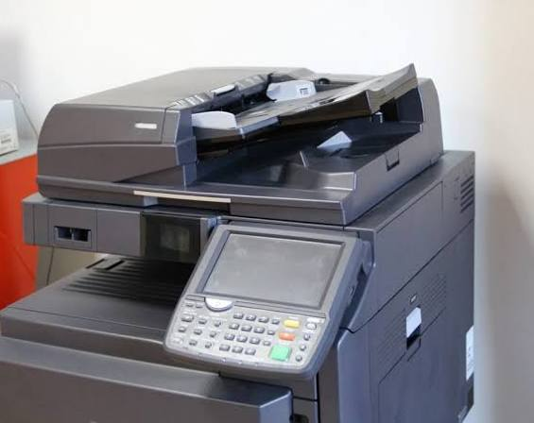
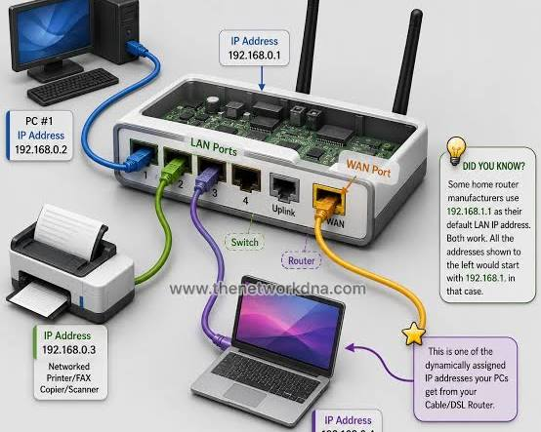
Precious Fikile Mkhize

